Random Walk

This test will display the RNG at work. Instead of displaying the countless loop of numbers, we made a program that represents what they call a random walk. Basically, the RNG functions the same but in a different way of producing random outputs. This test will also how they differ from each other. Each program runs are looped 10,000 times to see a pattern and each number 1-4 is correspondent to where the walk should go. If they go over the screen the walk then be reset back to default place.

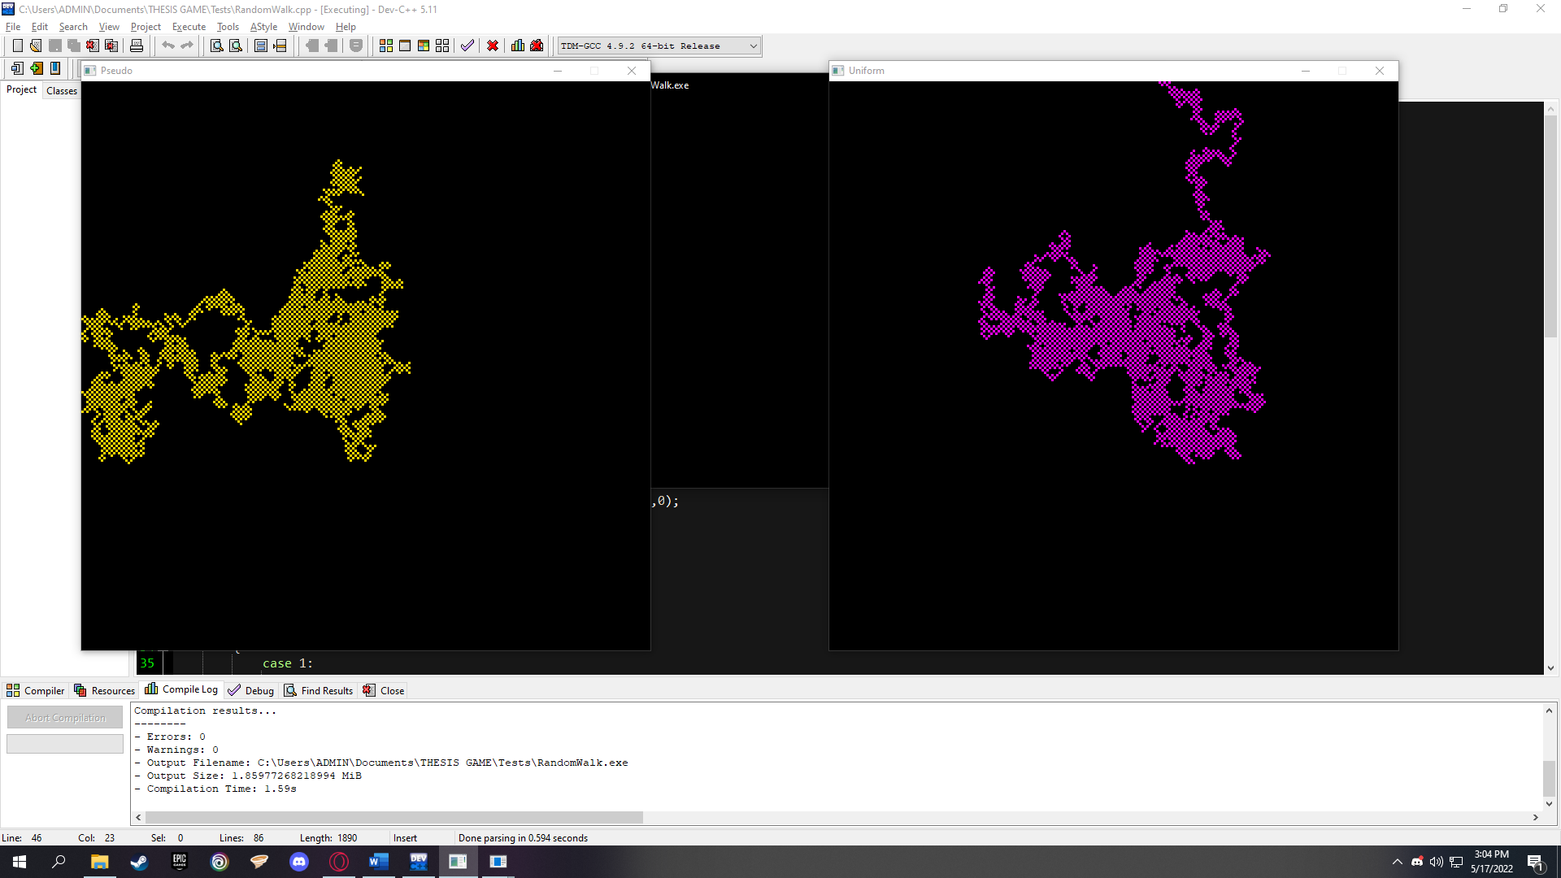First run:

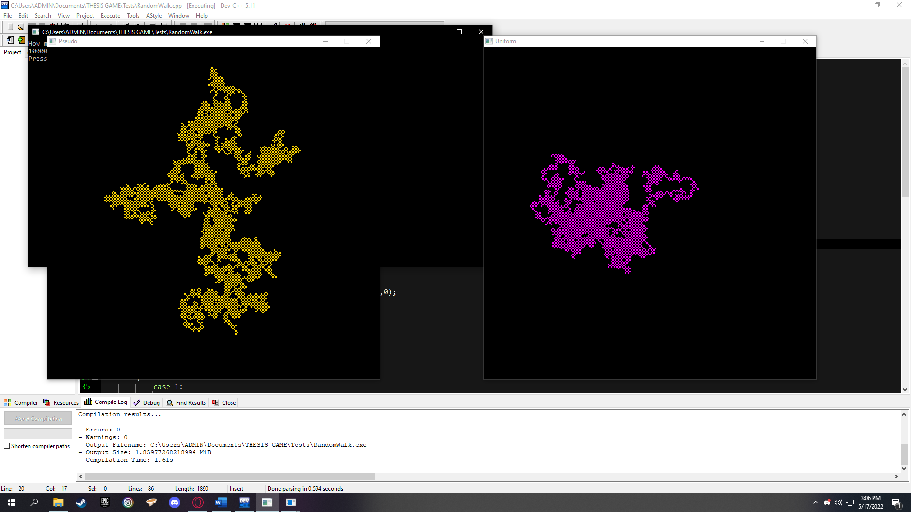Second run:

Third run:

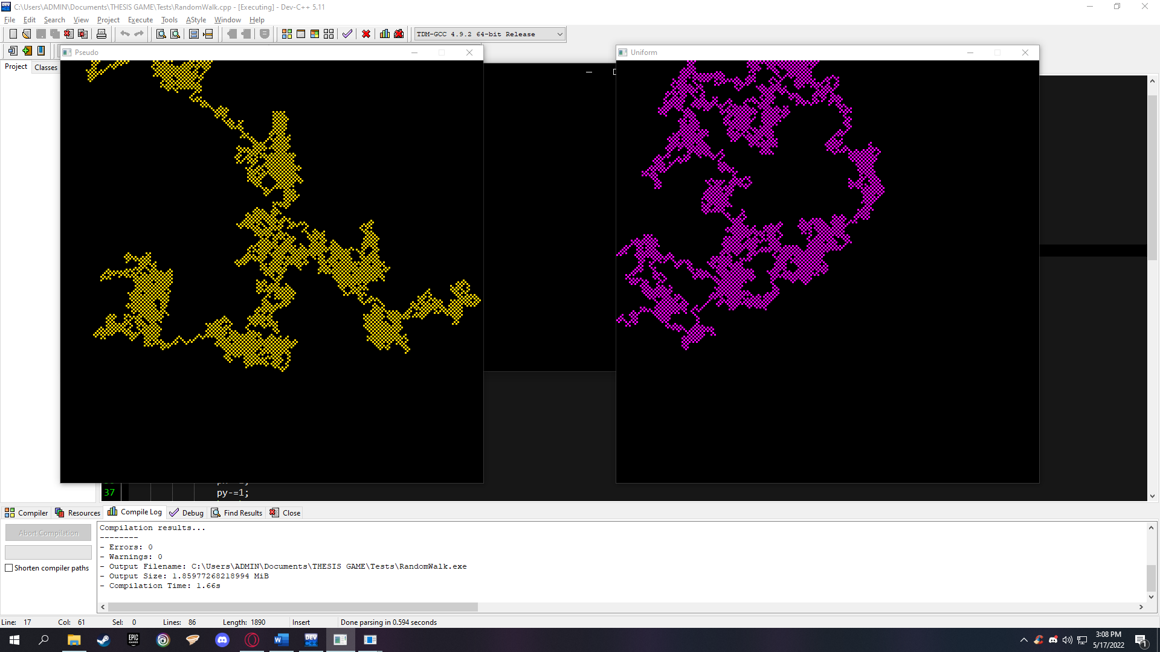The runs show that Pseudo-Random spreads too much than Uniform Distribution. This means that outputs have at least the probability of the next random output is based on the last output. Uniform Distribution on the other hand, spreads too thin that is because of the numbers have the same probability of being the output regardless that last output.